Friends and Family Comments July 2023
RESULTS: 103

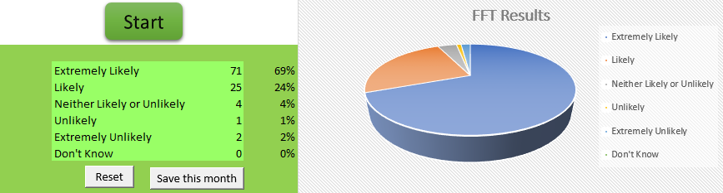

- Dr phoned me back same day and the receptionist was so helpful and always is
- Very good
- Very helpful and explained everything thoroughly
- Very good
- Very good doctor
- Happy with the service today
- Dr was very helpful. Listened to me very carefully. I was able to discuss everything with him. Best GP ever met
- Still cannot see a doctor face to face, always has to be a telephone consultation
- Doctor was nice
- I do not like having blood tests, cause they have to do it 2 to 3 times it stresses me out
- Always friendly and if they can get you an appointment they will definitely will. Receptionist and nurse
- The person who attended to me was really sweet
- Very good
- Very good and informative doctor
- Doctor was very helpful
- Very helpful and polite
- Very friendly receptionist doctor that I haven't seen before was very very helpful
- Very good
- I am happy with my GP, because I get ever an appointment and the Doctors are nice. Not any problems. Thank you so much
- Good
- They are very nice and small
- Very good staff
- Very caring doctor
- Sympathetic and not rushed
- Managed to see a doctor on same day as I phoned for an appointment. Dr was lovely and my issue was dealt with promptly and efficiently
- Today doctor listened to me carefully and understand my situation I am going through and explain me try to engage yourself he said do volunteer work or spend time in mosque I will try hard this time
- Very good
- I gave my answer because you asked
- Great service - quick efficient
- Managed to get the appointment I needed
- Very good
- Have never experienced the way she treated me fantastic and very very friendly and helpful 100% happy
- Felt like the appointment was very rushed
- Lovely helpful receptionist and the nurse that took my blood was also lovely and friendly
- Good
- Very good
- I went in on time and the nurse was very good
- Been here 55 years. Always get looked after
- Very good
- Saw one doctor 're problem then saw another doc for follow up
- Quick appointment on the day and given necessary medication
- Very good doctor
- I went for a prescription and got to see the doctor and had a blood test good service
- Because nurse was very helpful, friendly and kind
- Always get excellent service
- My appointment was straightforward and on time
- Efficient and professional
- Good
- Steve the paramedic is a great addition to the practice. He is a friendly, caring man and very patient too. I think the practice is brilliant
- Very professional
- Because the doctor was friendly & helpful
- Listening to what I was saying. Looked into it and phoned me back the next day
- I got to see a GP the very same day, the follow up treatment started immediately
- They were very helpful they explained things so I understood everything that I needed to do I was happy with the outcome
- Listened to what I had to say and gave good advice
- Excellent service
- Went in on time
- Good listen and very professional
- Quick, seen before my time and out in 5 minutes
- Very kind and understanding and very helpful and caring
- Doctor Halliwell was very nice. She was thorough with her questions and examination and was very polite. Felt she wanted to help and not just get me out the door as quick as she could
- Took blood well
- Please, please, please... don't let doctor Christopher Sefton leave... I had an underline issue for 5yrs. I have been tested for cancer, thyroid issues gastric issues and no resolve from any doctor... he did a simple test and those issues have gone. But got Down to the possible causes... This may be anonymous but I will be telling him at my next visit. The longstanding doctors should take lessons from him
- Very good
- Brilliant reception team. Always helpful and polite. Also was treated with respect and the Nurse too was helpful
- Gave me prescription that's seems to work
- Good staff and doctors thanks for them
- My doctor went over everything I needed to know and was extremely helpful
- It was professional and kind
- Pleased because of how they operate. I admire the way they run there day to day thing, good trained staff as well. Very good
- Pleasant young doctor that tried to help
- Polite, pleasant staff who kept me fully informed of the procedure throughout
- It was professional and kind
- Really caring junior GP who listened to my concerns
- Good
- The staff & doctor show me respect & listen to me in a caring way

